Clean Water Land and Legacy Amendment
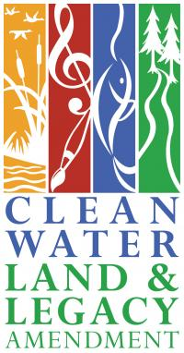
The purpose of the Clean Water Legacy Act is to ensure that all of Minnesota’s waters meet state and federal water quality standards. The Act is funded by the Clean Water, Land and Legacy Amendment. Which was passed on November 4th 2008 with a 56% vote. This amendment increased the sales and use tax rate by 3/8th of one percent. This tax began on July 1st, 2009, and will continue through 2034.
The Amendment dollars are divided into 4 separate funds. The Outdoor Heritage fund, Parks and trails fund, Arts and Cultural Heritage Fund, and the Clean Water Fund.
Outdoor Heritage fund:
Restoration, protection and enhancement of wetlands, prairies, forests and habitat of fish and game.
Parks and trails fund:
Gives support to parks and trails of regional or statewide significance. Providing funding for the development, maintenance, and acquisition of parks areas. Alongside support for AIS work and supplementing other funding sources.
Arts and Cultural Heritage Fund:
Funds projects for arts, education, access and preservation of Minnesota history.
Clean Water Fund:
Protect, enhance, and restore water quality in lakes, rivers, streams, and groundwater by funding maintenance projects. Such as water quality monitoring, restoration projects, storm and wastewater, and nonpoint pollution prevention.
RLWD has some projects that were partially funded by the Clean Water Fund. So be sure to keep an eye out for these signs.
For more information, please go to: https://www.lcc.mn.gov/

